

NATIONAL POLICE COMMISSION

**PHILIPPINE NATIONAL POLICE, POLICE REGIONAL OFFICE CALABARZON**

**CAVITE POLICE PROVINCIAL OFFICE**

**CARMONA MUNICIPAL POLICE STATION**

J.M. Loyola Street, Brgy. Maduya, Carmona, Cavite

December 2021

2021-12-524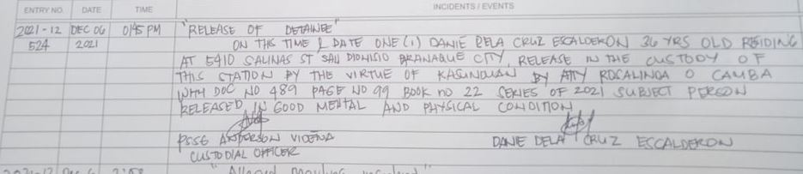

2021-12-526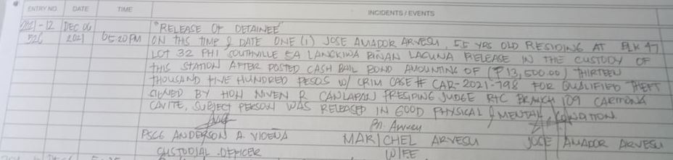

2021-12-533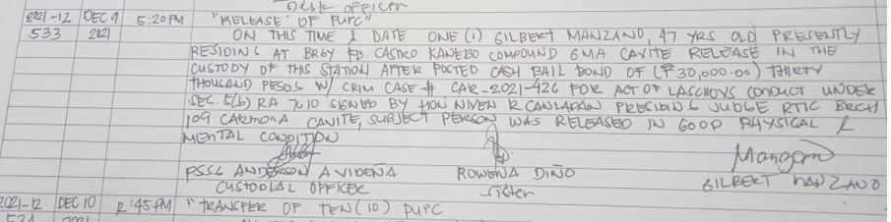

2021-12-534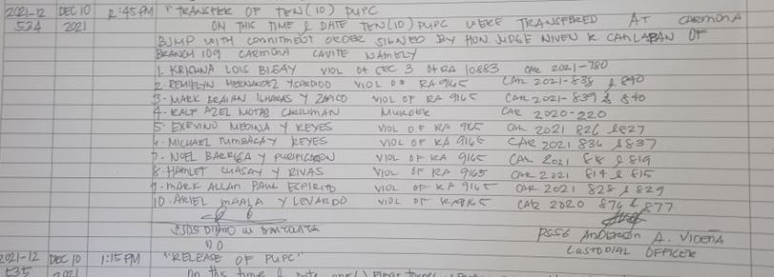

2021-12-535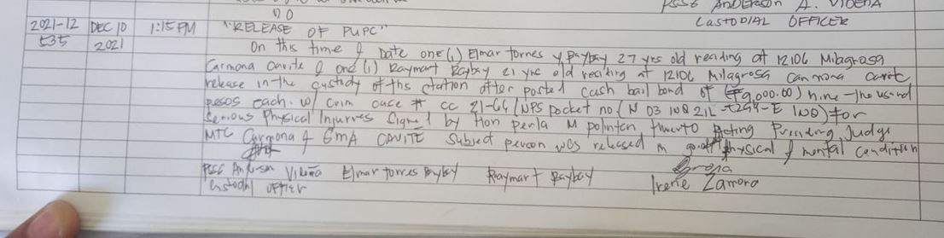

2021-12-536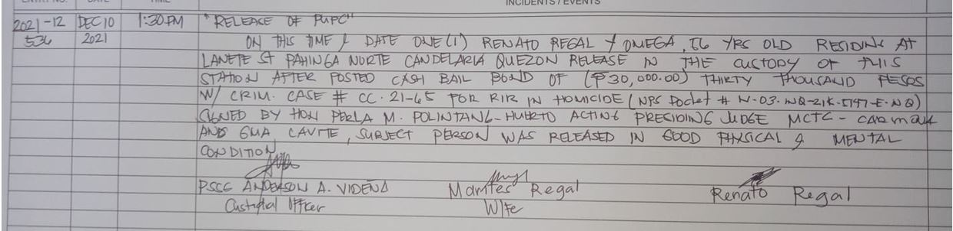

2021-12-539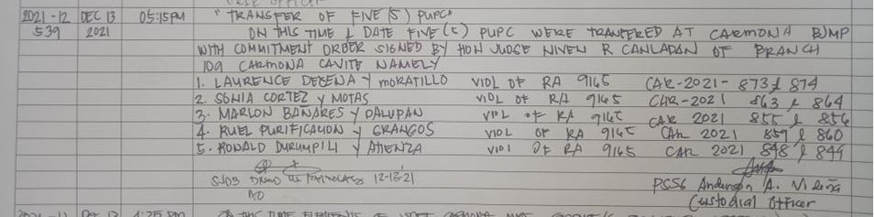

2021-12-547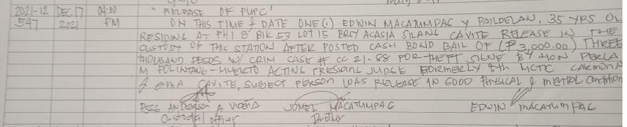

2021-12-558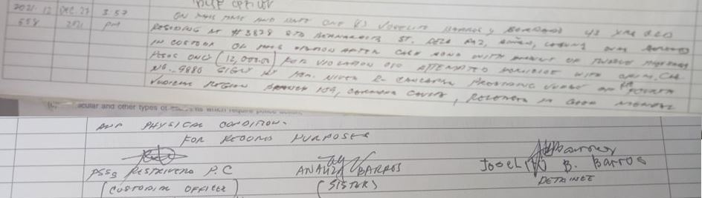

2021-12-560